Assessment : Lab Assignment 01
Student Name : Vasukumar Patel
Lab Professor Name : Dr. James Mwangi
Lab Section Number : 343
Due Date : October 6th (23:59 PM)

Understand the problem
- Single Cylinder’s volume formula: π r² h [1].
- Formula for the cylinder pyramid volume: π r² h + π (r*0.8)² h + π (r*0.6)² h
- Sample Table
r^2 | h | Answer
0.5 | 2 | 3.142
2 | 4 | 100.531
3 | 9 | 508.938

UML Class Diagram(s)

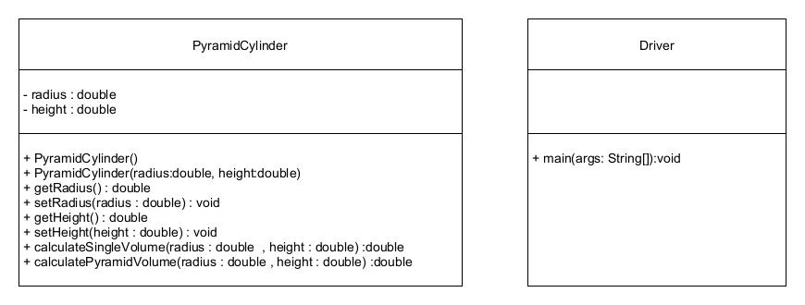

Pseudocode

- Pseudocode for PyramidCylinder.java

------------------------------------------------------------------------------------------------

- Start
- Import Scanner
- Class Driver
- Method main
- Create Scanner display
Output "Enter the value of the radius: "
Read radius
Output "Enter the value of the height: "
Read height
- Create Object
theResult = new PyramidCylinder(radius, height)
Declarization
String message = "The Volume of the total Pyramid Cylinder is: "
- printf(message)
- Object calls Method
: printf(theResult.calculatePyramidVolume(radius,height)) to three decimal
Declarization
String whomade = "The program is created by "
- printf(whomade + "Vasukumar Patel")
- Stop

------------------------------------------------------------------------------------------------

- Pseudocode for Driver.java
------------------------------------------------------------------------------------------------

- Start
- Import Math
- Class PyramidCylinder
Declarization
double radius
double height
- Construtor PyramidCylinder(radius,height)
this.radius = radius
this.height = height
- Construtor End
- Mathod calculateSingleVolume(radius,height)
return Math.PI*Math.pow(radius,2)*Math.abs(height)
- Mathod End
- Mathod
calculatePyramidVolume(radius,height)
theTotalVolumeFirst = calculateSingleVolume(radius,height)
theTotalVolumeSecond = calculateSingleVolume(radius*0.8,height)
theTotalVolumeThird = calculateSingleVolume(radius*0.6,height)

theTotalVolume = theTotalVolumeFirst + theTotalVolumeSecond + theTotalVolumeThird

return theTotalVolume
- Mathod End
- Stop

--------------------------------------------------------------------------------------------------------------

Algorithm Test Table

Input | Output | Expected Output | Description
5  5 | Enter the value of the radius: 5  Enter the value of the height: 5  The Volume of the total Pyramid Cylinder is: 785.398  The program is created by Vasukumar Patel | Enter the value of the radius: 5  Enter the value of the height: 5  The Volume of the total Pyramid Cylinder is: 785.398  The program is created by Vasukumar Patel | The program should take two inputs (which are 5 and 5) and give one output (which is 785.398)  Also, the programmer name should be written by the computer after leaving one line from the output.
0.2  -0.4 | Enter the value of the radius: 0.2  Enter the value of the height: -0.4  The Volume of the total Pyramid Cylinder is: 0.101  The program is created by Vasukumar Patel | Enter the value of the radius: 0.2  Enter the value of the height: -0.4  The Volume of the total Pyramid Cylinder is: 0.101  The program is created by Vasukumar Patel | The program should take two inputs (which are 0.2 and 0.4) and give one positive output (which is 0.101) (due to Math.abs )  Also, the programmer name should be written by the computer after leaving one line from the output.
-5  5 | Enter the value of the radius: -5  Enter the value of the height: 5  The Volume of the total Pyramid Cylinder is: 785.398  The program is created by Vasukumar Patel | Enter the value of the radius: -5  Enter the value of the height: 5  The Volume of the total Pyramid Cylinder is: 785.398  The program is created by Vasukumar Patel | The program should take two inputs (which are - 5 and 5) and give one positive output (which is 785.398)  Also, the programmer name should be written by the computer after leaving one line from the output.

- Flowchart

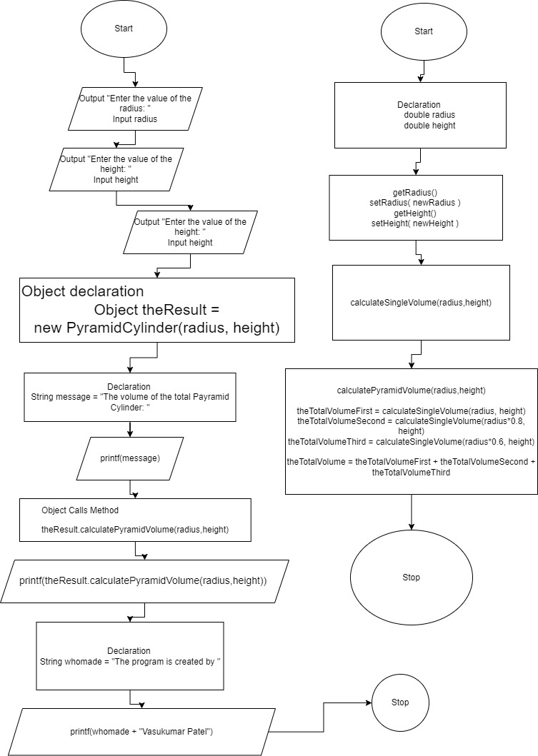

Java Program Test Table
Input | Output | Expected Output | Description
0.5  0.10 | 0.157 | 0.157 | Valid Output
-2  3 | 75.398 | 75.398 | Valid Positive Output
1.2  0 | 0.000 | 0.000 | Valid Output
1  Vasu | Error | Error | Invalid Output  [ Error : ]  Exception in thread "main" java.util.InputMismatchException  at java.base/java.util.Scanner.throwFor(Scanner.java:947)  at java.base/java.util.Scanner.next(Scanner.java:1602)  at java.base/java.util.Scanner.nextDouble(Scanner.java:2573)  at Driver.main(Driver.java:13)
-1  (1/0) | Error | Error | Invalid Output  [ Error: ]  Exception in thread "main" java.util.InputMismatchException  at java.base/java.util.Scanner.throwFor(Scanner.java:947)  at java.base/java.util.Scanner.next(Scanner.java:1602)  at java.base/java.util.Scanner.nextDouble(Scanner.java:2573)  at Driver.main(Driver.java:13)
0.2  0.2.2 | Error | Error | Invalid Output  [ Error: ]  Exception in thread "main" java.util.InputMismatchException  at java.base/java.util.Scanner.throwFor(Scanner.java:947)  at java.base/java.util.Scanner.next(Scanner.java:1602)  at java.base/java.util.Scanner.nextDouble(Scanner.java:2573)  at Driver.main(Driver.java:13)

References

[1] | Byjus.com, "Volume of a cylinder," Byju's, [Online]. Available: https://byjus.com/maths/volume-of-a-cylinder/. [Accessed 01 10 2024].

